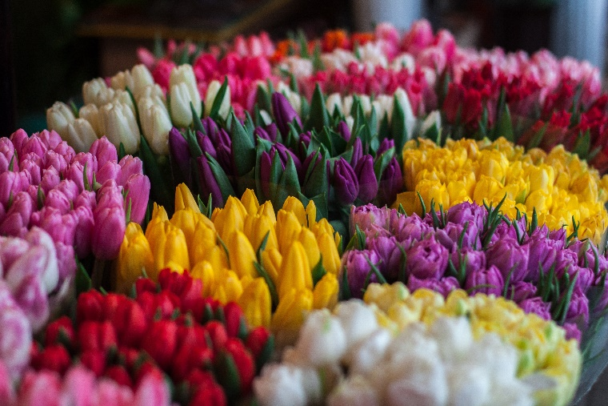

SJR-HSA Spring Flower Sale

*** ALL ORDERS ARE DUE FRIDAY, April 16 ***

Pickup is Thursday, May 6, 2:00-6:00 in SJR parking lot

Please send cash or check payable to SJR-HSA to Suzanne Sorge ℅ Joseph, grade 4

*** ABSOLUTELY NO ORDERS WILL BE TAKEN AFTER FRIDAY, April 16 ***

Name______________________________________

Flowering Annual Combinations and Deck & Porch Planters
 | Quantity | Total price
6.5” terracotta pot $8
6.5” assorted gerbera daisies (regular pot) $8
8” terracotta pot $12
10” terracotta pot $18
12” terracotta pot $20
14” terracotta pot $25
10” terracotta pot with black hoop trellis reading “WELCOME” $22
16" tulip banded antiqued deck pots $35

Flowering Annual Combinations Hanging Baskets
 | Quantity | Total price
8” hanging basket $12
10” hanging basket $15
12” hanging basket $25
14” coconest hanging basket $35

3.5” Herbs $5 each or 3 for $12
 | Quantity | Total price |  | Quantity | Total Price
basil |  |  | oregano
chives |  |  | parsley
cilantro |  |  | rosemary
dill |  |  | sage
lavender |  |  | spearmint
marjoram |  |  | thyme
SPECIAL 10” mixed herb garden $15 |  |  | X | X | X

Total # of plants________ Total $ amount due___________

