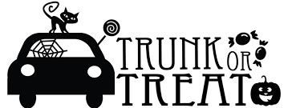

Friday October 29, 2021
5:30pm – 8:30pm
SJR Parking Lot
*Early set up can begin at 4:30pm*

Put on your Halloween costumes, decorate your vehicle
and join us for a night of SJR Family Fun!

$20 per vehicle (spots with electricity will be limited)

In order to run this event as safely as possible:
- Please bring store bought, individually wrapped Candy or treats
- Only family members within the household can attend
- There must be someone at the vehicle at all times to hand out candy

This year we have decided to offer a dinner package

Family Box: $8.00
5 Hotdogs
4 Bags of Chips
4 Bottles of Water

Individual/Additional)
1 Hotdog $1.50
Bags of Chips .75 cents
1 Bottle of Water .75 cents

Please send in cash or check (made payable to SJR HSA) to Gina Smart c/o Miles Smart Grade 2
$20 per vehicle plus any selected Food items
Forms are due by October 22nd

Family Food Box ______ # of boxes
Individual Hot Dog ______ # of Hotdogs
Individual Bag of Chips ______ # bags of chips
Individual Bottled Water ______ # bottles

People attending: _____ # Adults _____ # Kids

Electricity (circle one): YES NO

Family Name _________________________________________

Total Amount Enclosed _______________

