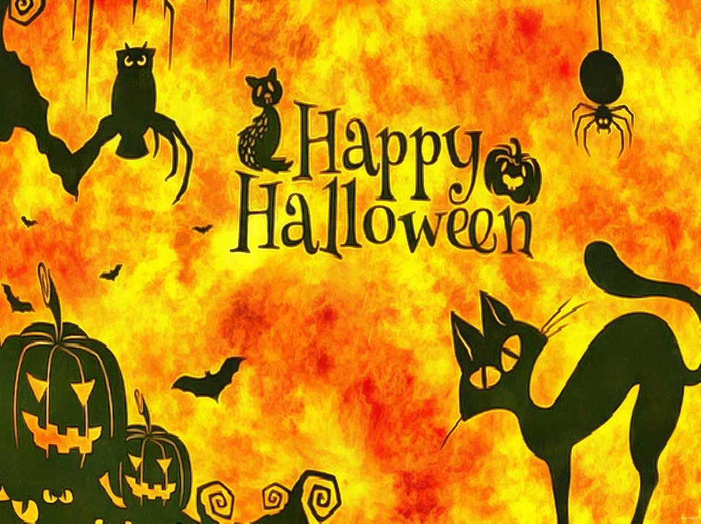

**4th, 5th and 6th Halloween Costume Dance**

**Location: SJR School Cafeteria**

**Date : October 23rd**

**Time: 6:30pm—9:30pm**

**Cost : $10.00 per child**

**Snack and refreshments will be served**

**Fun Night of Dancing and Games**