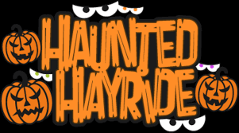
7th & 8th Grade
Haunted Hayride

Friday, October 22nd
Froehlich’s Farm
3143 York Rd
Furlong, Pa

6-9pm
$20 includes:
Haunted Hayride ticket,
Pizza, drinks, snacks & s’more kits,
entrance to grounds with live music, bonfires, etc.
(Other food is available for purchase from food trucks & farm)
*SJR Parent Chaperones will be present*

Return your forms and payment of cash or check by Wednesday October 20th
To: Heather Bargerhuff ℅ Jacob Bargerhuff Gr.8
(Checks made payable to SJR HSA)

You will receive an email confirming that I received your payment, Any questions reach out to:
Heather Bargerhuff 267-978-1919 or heatherbargerhuff@gmail.com
------------------------------------------------------------------------------
7th & 8th grade Haunted Hayride

Student Name:_______________________________Food Allergies:______________________
For confirmation: Parent name _______________________________
Email:___________________________________________
CellPhone #___________________

